192011340

P.keerthi

Experiment no:8

Data Link Layer Traffic Simulation using Packet Tracer Analysis of ARP

AIM:

To configure the data link layer traffic Simulation using Packet Tracer Analysis of ARP

REQUIREMENTS:

1. End device - They are the devices through which we can pass message from one device to another and they are interconnected.

2. Switch/Hub - Interface Between two devices.

3. Cable - Used to connect two devices.

4.server

Procedure:

STEP 1: Click on end devices, select generic Pc’s drag and drop it on the

window. Click on SWITCH drag and drop it on the window. and also connect the server to the pc''s

STEP 2: Select the straight through cable and connect all end device to switch. Assign the IP address for all end devices. (Double click the end device Select →

desktop → IP configuration static)

STEP 3: Now set the IP address to Host A (192.168.1.1) in static mode. Similarly set IP address for Host B (192.168.1.2) and Host C (192.168.1.3)

STEP 4: To view the IP address, give ipconfig command in command prompt. Using ping command, we can establish communication between two host devices.

STEP5: Now display the packet transmission in simulation mode.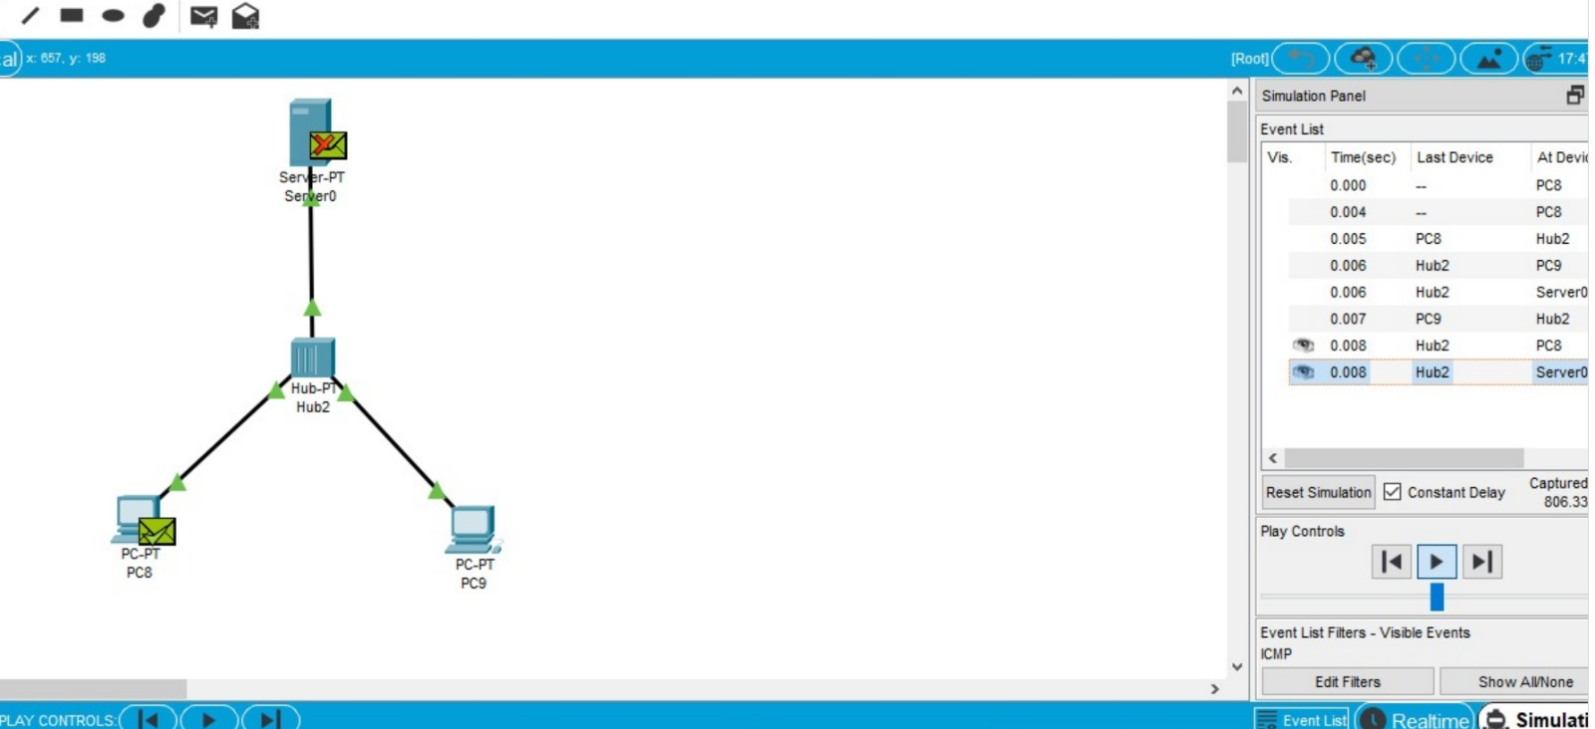

RESULT: the configuration of data link elayer of traffic Simulation is successful